**T8 - IAM**

**(Identity and Access Management)**

**IAM USERS CREATED:**

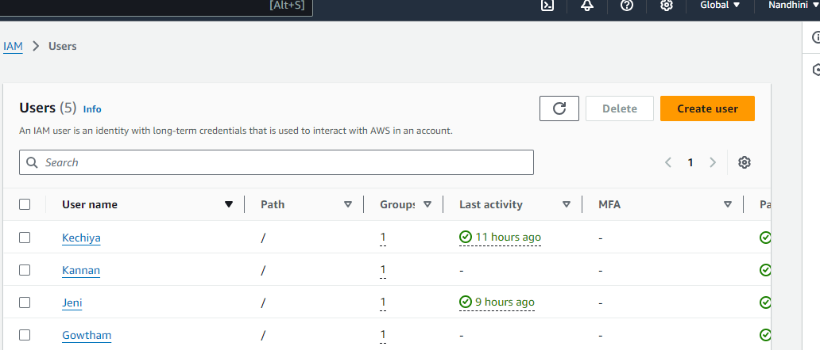

**EC2 POLICY ATTACHED:**

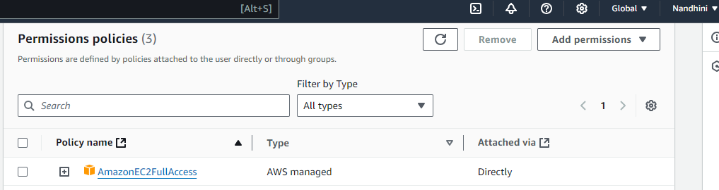

**EC2 full access provided to IAM users (Gowtham,Jeni,Kechiya and Kannan)**

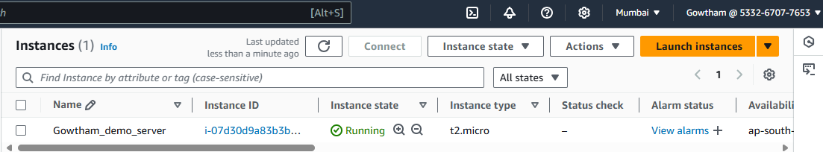

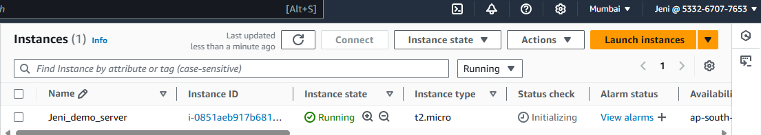

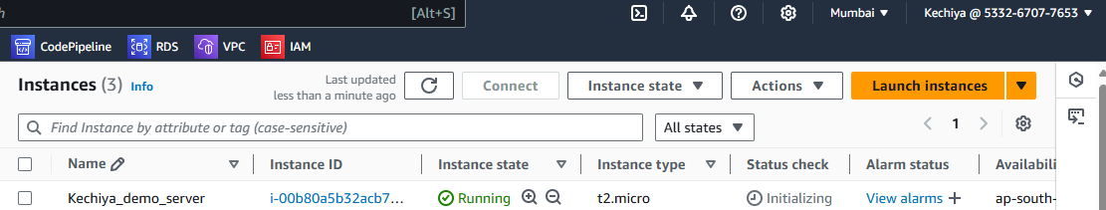

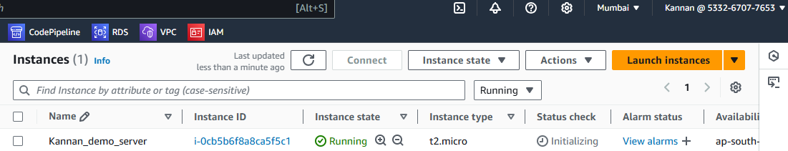

**S3 BUCKET created and uploaded image into object:**

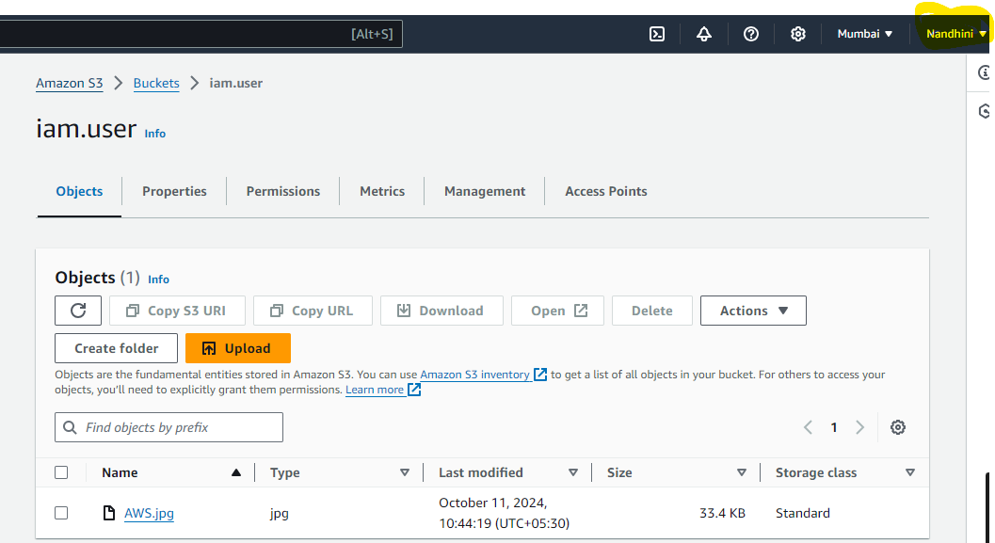

**GROUP CREATED:**

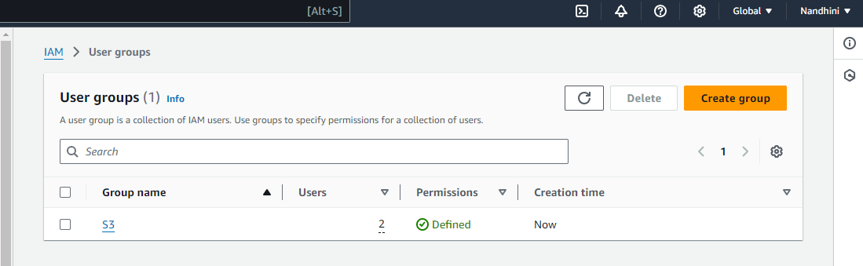

**Added Users in Group:**

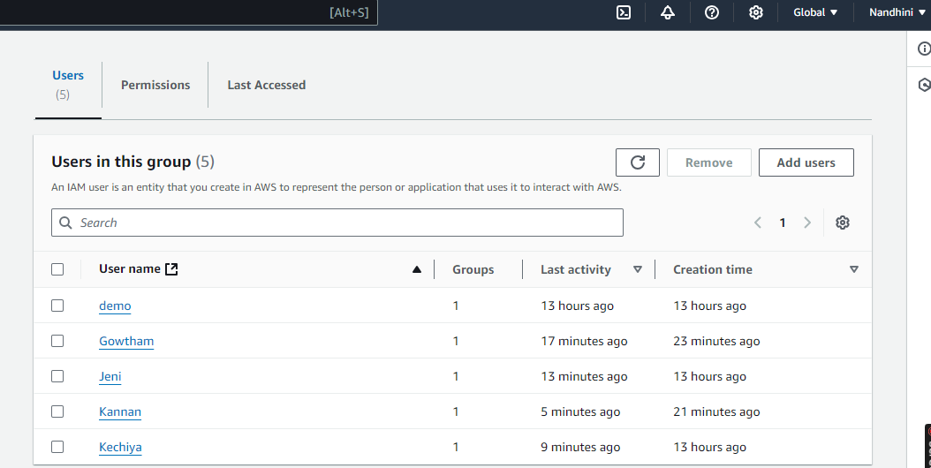

**Group Policies:**

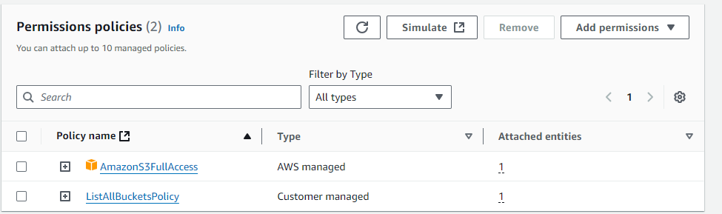

**Provided group policy S3 full access to all IAM Users (Gowtham, Jeni, Kechiya and Kannan)**

